**Project and Developer Details:**

|  |  |
| --- | --- |
| **Project Name:** | Sporty Shoes Admin Portal |
| **Developer:** | Vema Venkatesh Gangodi |
| **E-Mail:** | [venkatesh.gv484@gmail.com](mailto:venkatesh.gv484@gmail.com) |

**Core concepts used in the project:**

* Spring Boot
* Spring Boot JDBC
* Spring Boot MVC Framework
* JSPs
* Database Operations
* Basic HTML and CSS
* Maven

**GitHub repository Link:**

<https://github.com/venkateshgv484/PGP-FSWD-PROJECT-3>

**Unique Selling Points:**

* **Login option**
  + User cannot access the application without login
* **Academy Subjects:**
  + User can add/maintain/delete the subjects
* **Academy Teachers:**
  + User can add/maintain/delete the teachers
* **Academy Classes:**
  + User can add/maintain/delete the classes
  + There is an option to assign subject & teachers to the class
* **Academy Students:**
  + User can add/maintain/delete the students
  + Only one class is allowed to a student

**Output:**

**Admin Login Page**

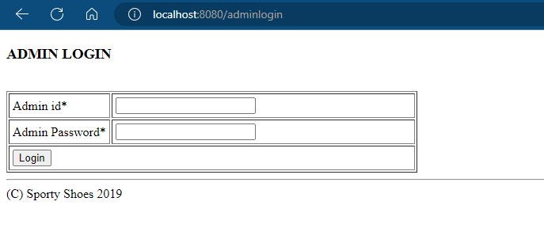

**Dashboard Page**

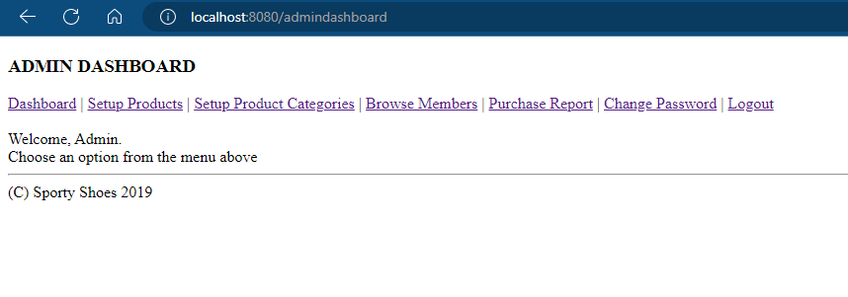

**Product Category Page**

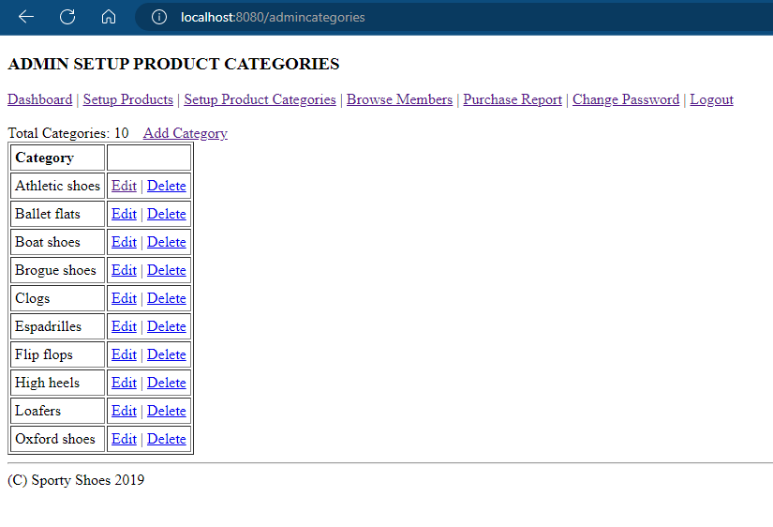

**Product Page**

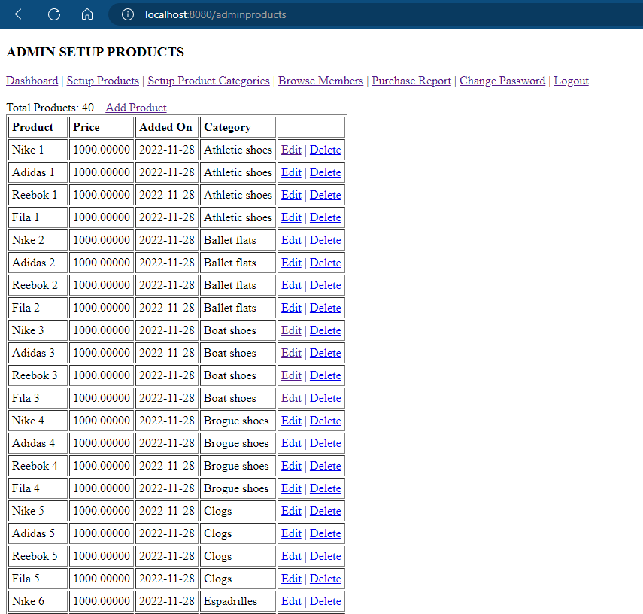

**Members Report Page**

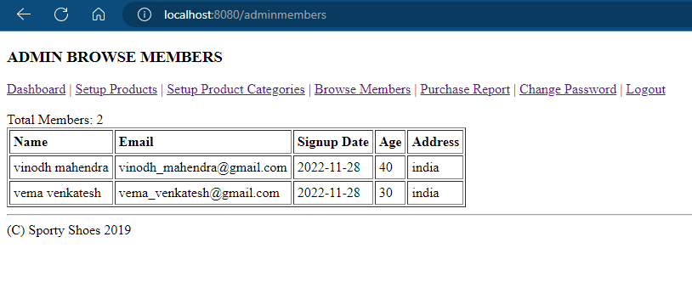

**Purchase Report Page**

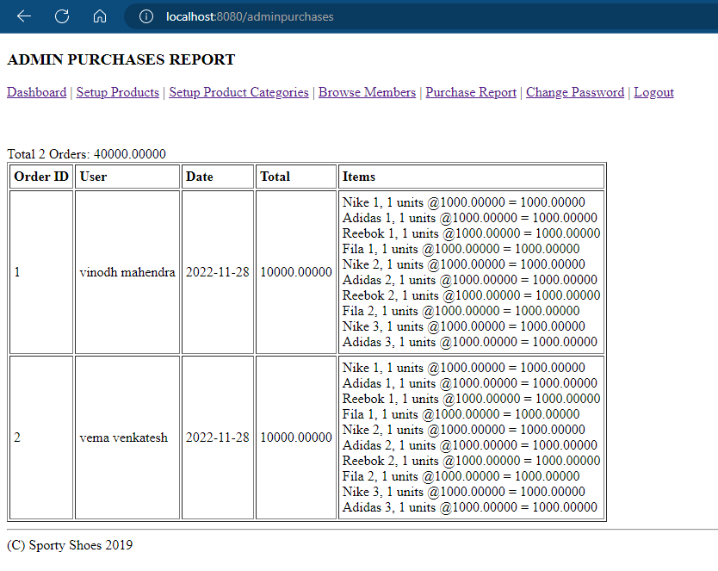

**Change Password Page**

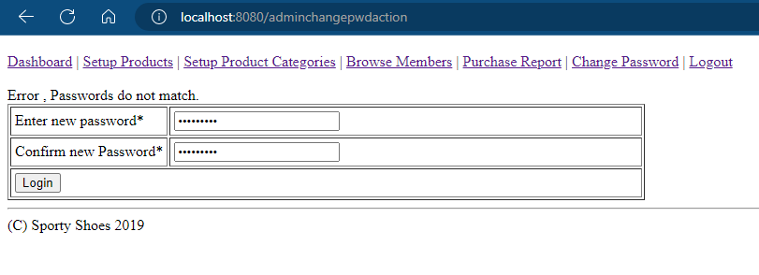

**Home Page**

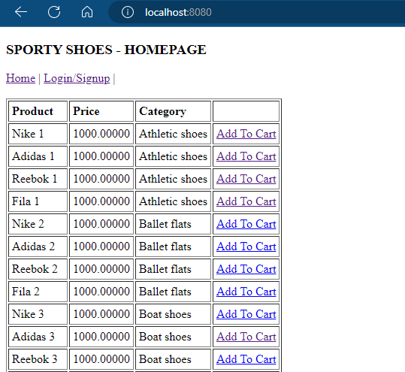

**Member Registration Page**

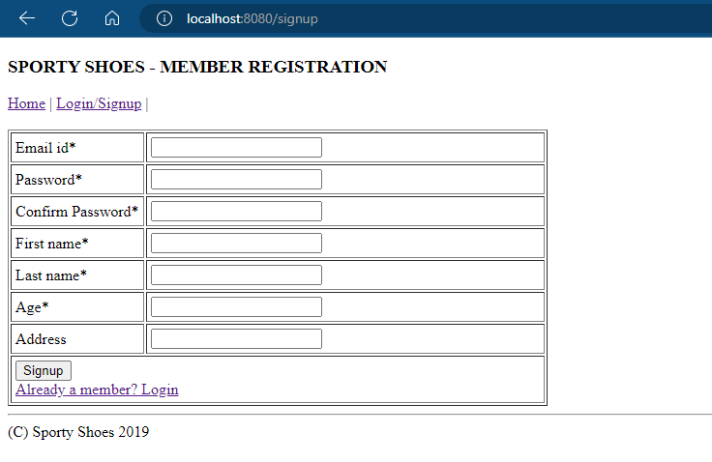

**User Login Page**

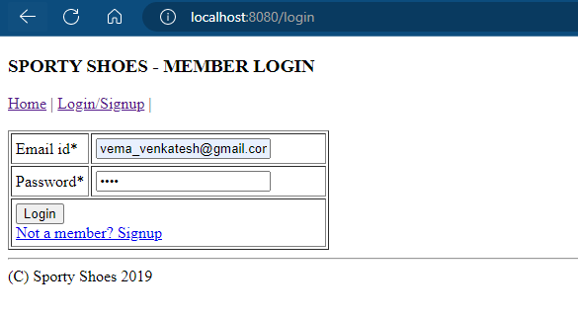

**Edit Profile Page**

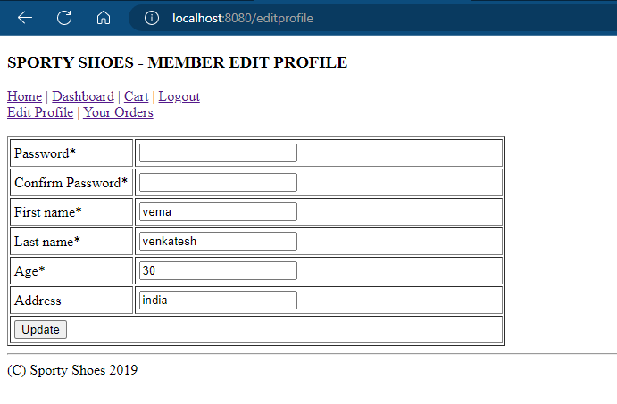

**Cart Page**

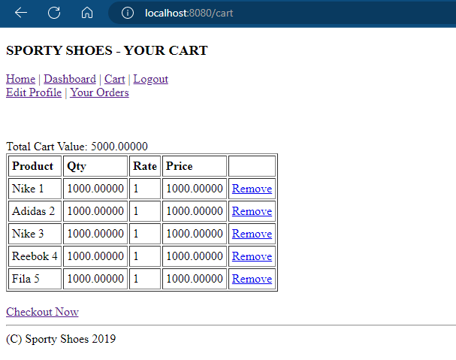

**Checkout Page**

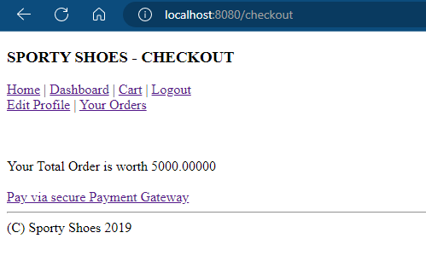

**Payment Gateway Page**

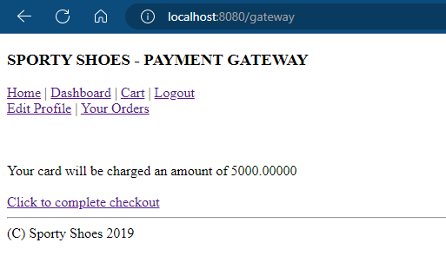

**Purchase Confirmation Page**

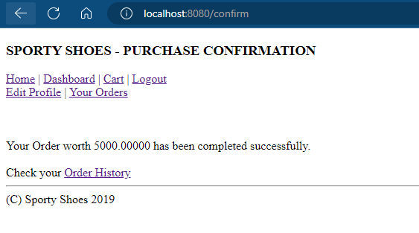

**Orders Page**

